SECTION 1: Hands-On Demonstration

Part 1. Installing Windows DFS and Creating Network Shares

Part 2. Configuring DFS

1. the Review Settings and Create Namespace page (screen capture):

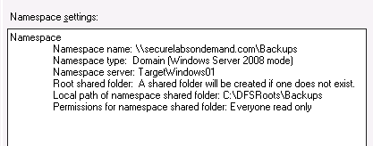

2. the Confirmation page (screen capture):

Forgot to take this screenshot.

3. the Namespace entries (screen capture):

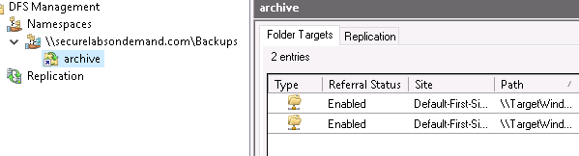

Part 3. Installing and Configuring Windows System Backup

1. the successful backup schedule on the Summary page (screen capture):

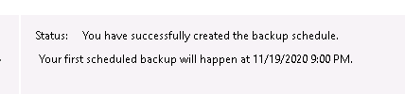

2. the contents of the TargetWindows01 backup folder (screen capture):

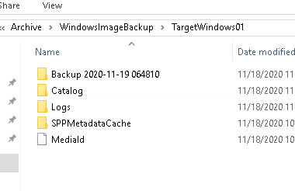

SECTION 2: Applied Learning

Part 1. Installing Windows DFS and Creating Network Shares

1. the net share results (screen capture):

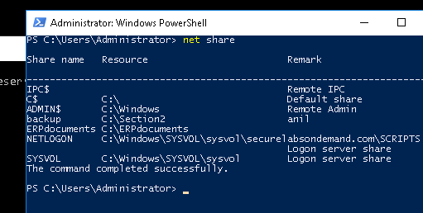

Part 2. Configuring DFS

Part 3. Create Script for Windows Backup to DFS

1. the contents of the ERPdocuments folder on the TargetWindows02 server (screen capture):

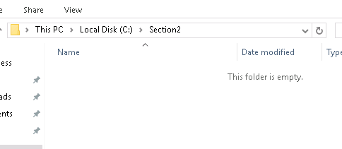

SECTION 3: Observation Summary

We RDP into TargetWindows01. We navigate to a windows powershell script file and run it. We then launch powershell, and install windows DFS namespace service. We then install windows DFS Replication service. Then we install Windows DFS management console. We switch to cmd. We create a new folder named archive and share it. We then RDP into TargetWindows02 and install Windows DFS Replication service. We also create the archive folder here and share it.

We then install windows server backup for for first remote machine and backup a folder. Then we observe the backup is actually created.

We connect to remotemachine1 and install the programs again. So we can create the directory to share. And we use the net share command to share it. We do the same for remotemachine2.